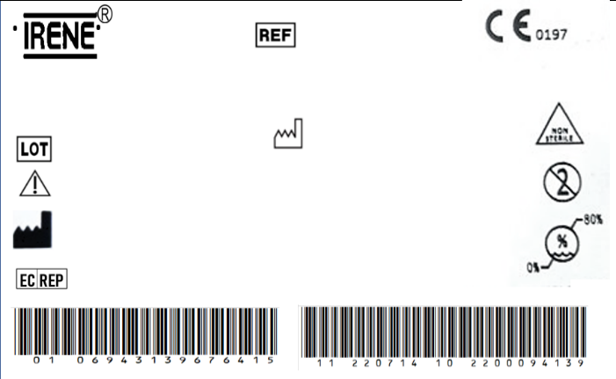

TORNILLO DE BLOQUEO HUMERO 4.0\*20mm TITANIO

6820

2027-07-14

2100006287

The implante should be sterilized before surgery.

TianJin ZhengTian Medical Instrument Co., ltd.

No. 318, Jingyi Road

Airport Economic Zone 300308 TianJin P.R. China

Bricon GmbH

EisenBahnstrasse 100, 78573 Wurmlingen, Germany



TORNILLO DE BLOQUEO HUMERO 4.0\*20mm TITANIO

6820

2027-07-14

2100006287

The implante should be sterilized before surgery.

TianJin ZhengTian Medical Instrument Co., ltd.

No. 318, Jingyi Road

Airport Economic Zone 300308 TianJin P.R. China

Bricon GmbH

EisenBahnstrasse 100, 78573 Wurmlingen, Germany